|  |  |
| --- | --- |
| DOOR LOCK SYSTEM | 4th Mechatronics  Faculty of Engineering  Assiut university  Presented to: DR. Khalil Ismail  Prepared by  Diaa Ahmed Riad  Mostafa Nasr Eldien Mohamed  Eslam Mansour  Hazem Ayman  Raed Abd Elhakiem |

***Table Of Content***

1 Abstract 2

2 Needed Hardware Components 3

3 Flow Chart 4

**3.1** **Main function** 4

4

**3.2** **Interrupt Admin Access flowchart** 5

**3.3** **Interrupt Student PC change flowchart** 6

4 Project Codes 7

5 Circuit simulation with PROTEUS 7

6 Question Answer 8

# Abstract

This project introduces a smart door lock system employing the ATmega16 microcontroller, integrating advanced features for enhanced security and user convenience. The system utilizes a combination of hardware and software components to create a robust and intelligent access control mechanism.

The ATmega16 microcontroller serves as the central processing unit, orchestrating the functionality of the entire system. User authentication is achieved through a keypad input system, where individuals enter a pre-programmed PIN to gain access.

# Needed Hardware Components

* ATmega 16 microcontroller
* LCD 16*2
* DC motor
* Buzzer
* Keypad
* Push buttons
* Transistors
* LEDs

# Flow Chart

For more obvious images of the flow chart in the peripheral files

## **Main function**

## 

## **Interrupt Admin Access flowchart**

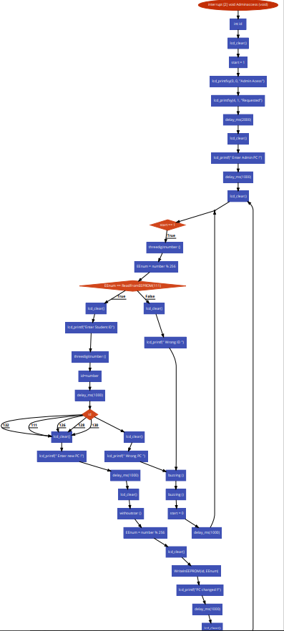

## **Interrupt Student PC change flowchart**

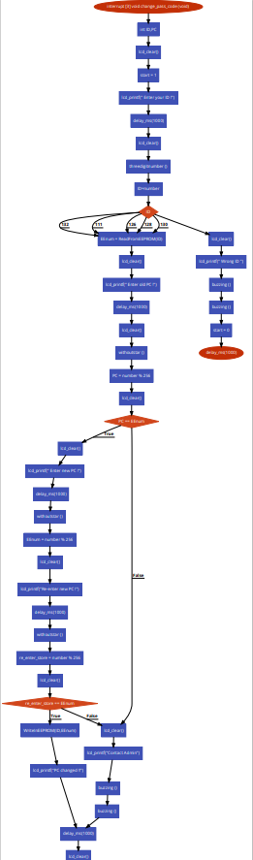

# Project Codes

It is very large to be put here, so it is existing in the peripheral files

# Circuit simulation with PROTEUS

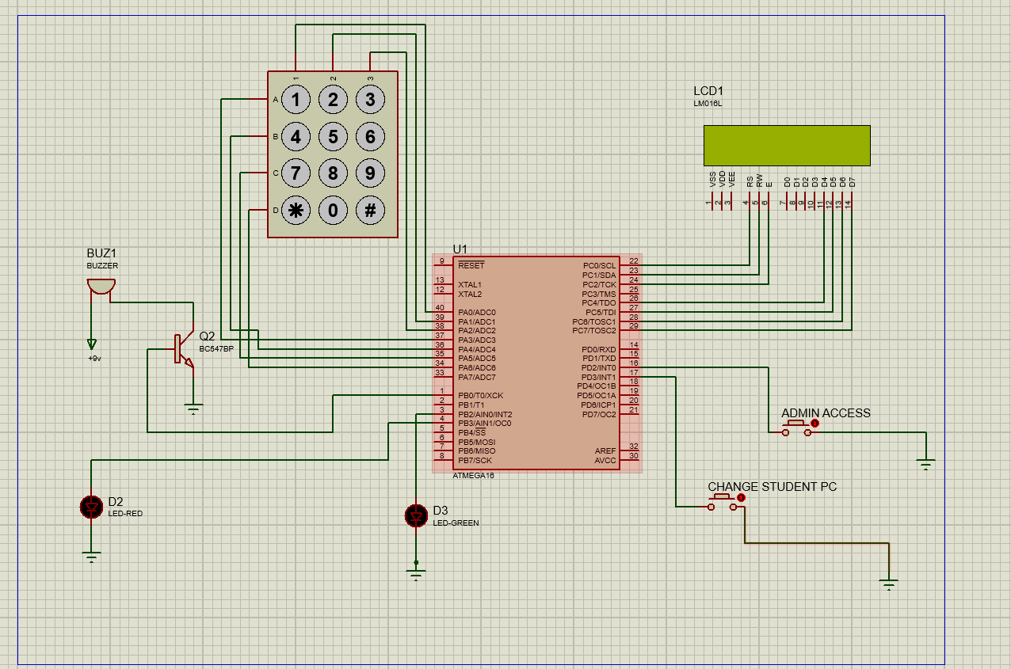

# Question Answer

We think that the Professor should have the high priority. So, it should stay the same as mentioned in Video. Because if there is any disagreement between them, professor can change the PC as he is the supervisor the lab

in addition, we think that it does not matter so much as the priority of the interrupt will be important only if the professor and the student press the push button at the same time and that is not logical. So, the arrange of them is not much important.